Food Management System

Use-Case-Realization Specification: Add Products

Version <1.0>

Revision History

|  |  |  |  |
| --- | --- | --- | --- |
| **Date** | **Version** | **Description** | **Author** |
| <24/12/2020> | <1.1> | Final Draft | Nguyen Thi Ngoc Anh |

Table of Contents

1. Introduction 2

1.1 Purpose 2

1.2 Scope 2

1.3 Definitions, Acronyms, and Abbreviations 2

1.4 References 2

1.5 Overview 2

2. Flow of Events—Design 2

3. Derived Requirements 2

Use-Case-Realization Specification: Add Products

# Introduction

## Purpose

This document describes how the Add Product Use-Case is realized within the design model, in terms of collaborating objects.

## Scope

This document applies to the Food Management System which will be developed by TAT Restaurant.

## Definitions, Acronyms, and Abbreviations

User – a person who use the system, can be customer.

Admin – administrator

## References

None.

## Overview

In the following section, Use-Case Realization Specification of the Add Product Use-Case of the Food Management System is provided in detail. The first section is a textual description of the Use-Case specification. The following section contains diagrams (sequence and collaboration diagrams) describing how the use case is realized in terms of collaborating objects. The third section includes class diagrams with relationships that participate in the realization of the use case. The last section is an analysis of all requirements, such as non-functional requirements, on the use-case realization that are not considered in the design model, but that need to be taken care of during implementation.

# Flow of Events—Design

|  |  |
| --- | --- |
| **Name** | Add Products |
| **Actor(s)** | Admin |
| **Brief Description** | Admin adds new dishes to the database |
| **Triggers** | Admin click to add items on dish details |
| **Pre-conditions** | Admin has successfully logged in |
| **Post-conditions** | Admin returns to the main screen  The new dish is successfully added |
| **Main Event Flow** | 1. Admin click on "add" on the main interface 2. The system displays a form for the admin to add a new item 3. Admin follow the form and press save 4. The system checks and saves information in the database 5. The system displays “add successfully” |
| **Exception Flow** | * 1. . The admin adds an existing item in the list of products   The system check and notify that dishes already exist  Admin add other dishes or exit |

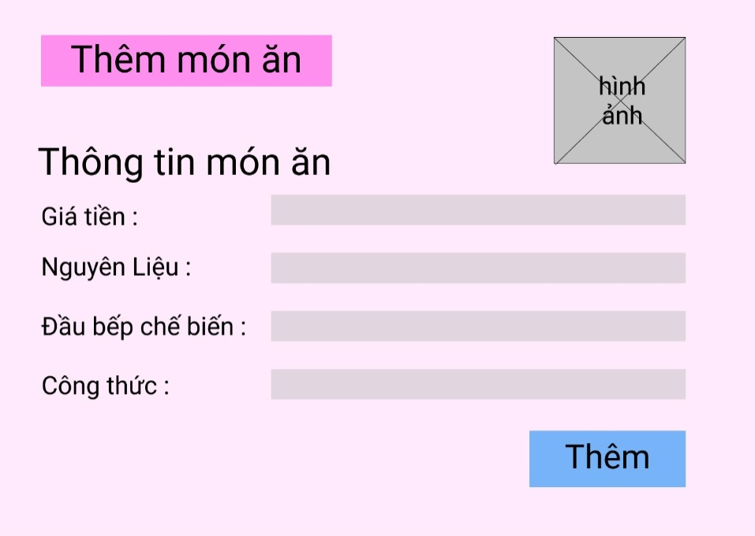

Sequence Diagram:

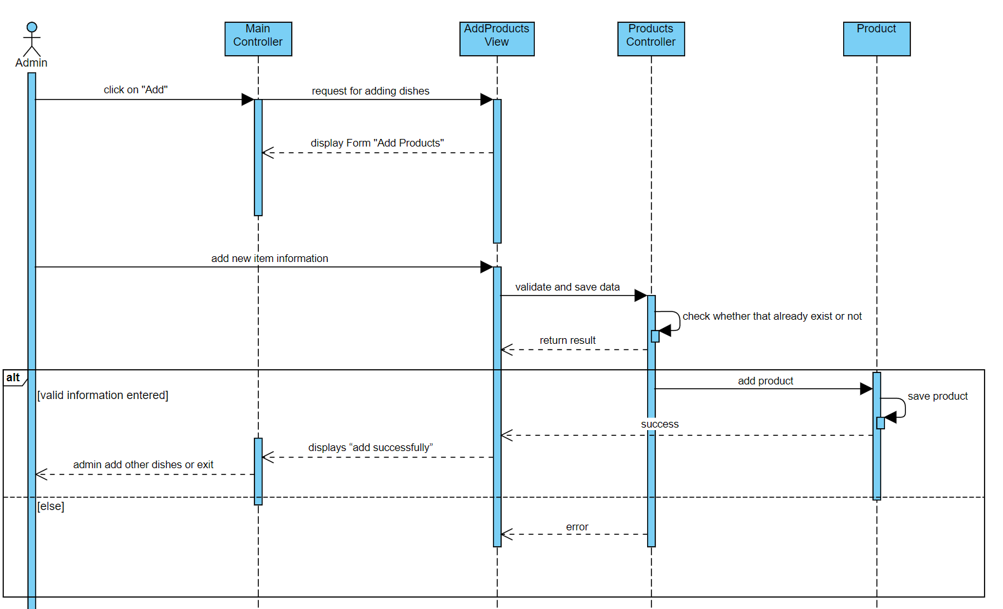

Class Diagram:

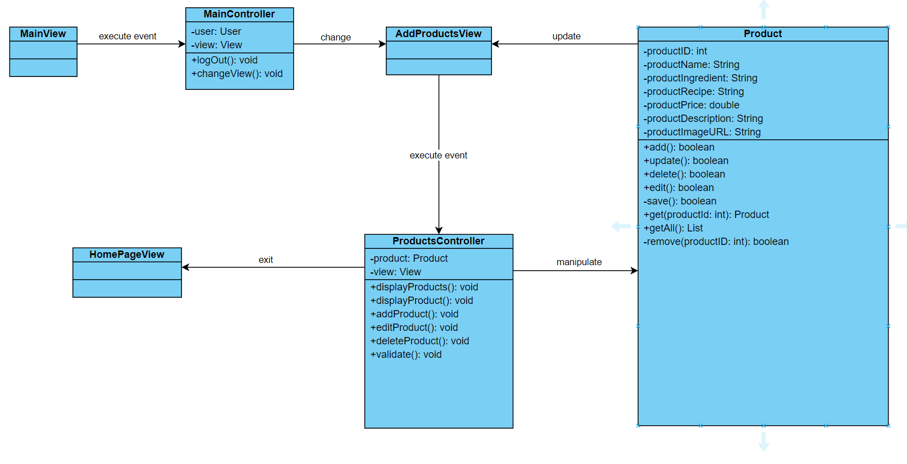

# Derived Requirements

None.